Who’s Behind Your Food?  In the spirit of the Thanksgiving season and the theme of ethical eating, take a moment to learn and reflect about the workers who bring your food to the table.  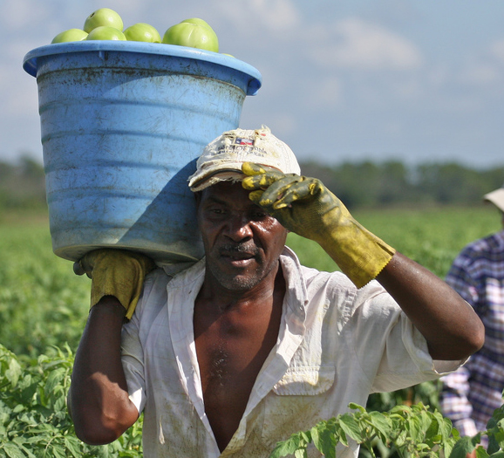  Take action to stand in solidarity with  - Turkey-processing workers who face severe preventable injuries on the job  - Restaurant workers whose employers don’t provide them with paid sick days  - Farmworkers in Florida who are picking tomatoes for poverty wages  Learn more and download materials, including a sample workshop about justice for food workers at: www.uusc.org/fieldtofork  (Use this space to write in your workshop details: Date, Time, Place) | In the spirit of the Thanksgiving season and the theme of ethical eating, take a moment to learn and reflect about the workers who bring your food to the table.  Who’s Behind Your Food?  Take action to stand in solidarity with  - Turkey-processing workers who face severe preventable injuries on the job  - Restaurant workers whose employers don’t provide them with paid sick days  - Farmworkers in Florida who are picking tomatoes for poverty wages  Learn more and download materials, including a sample workshop about justice for food workers at: www.uusc.org/fieldtofork  (Use this space to write in your workshop details: Date, Time, Place)
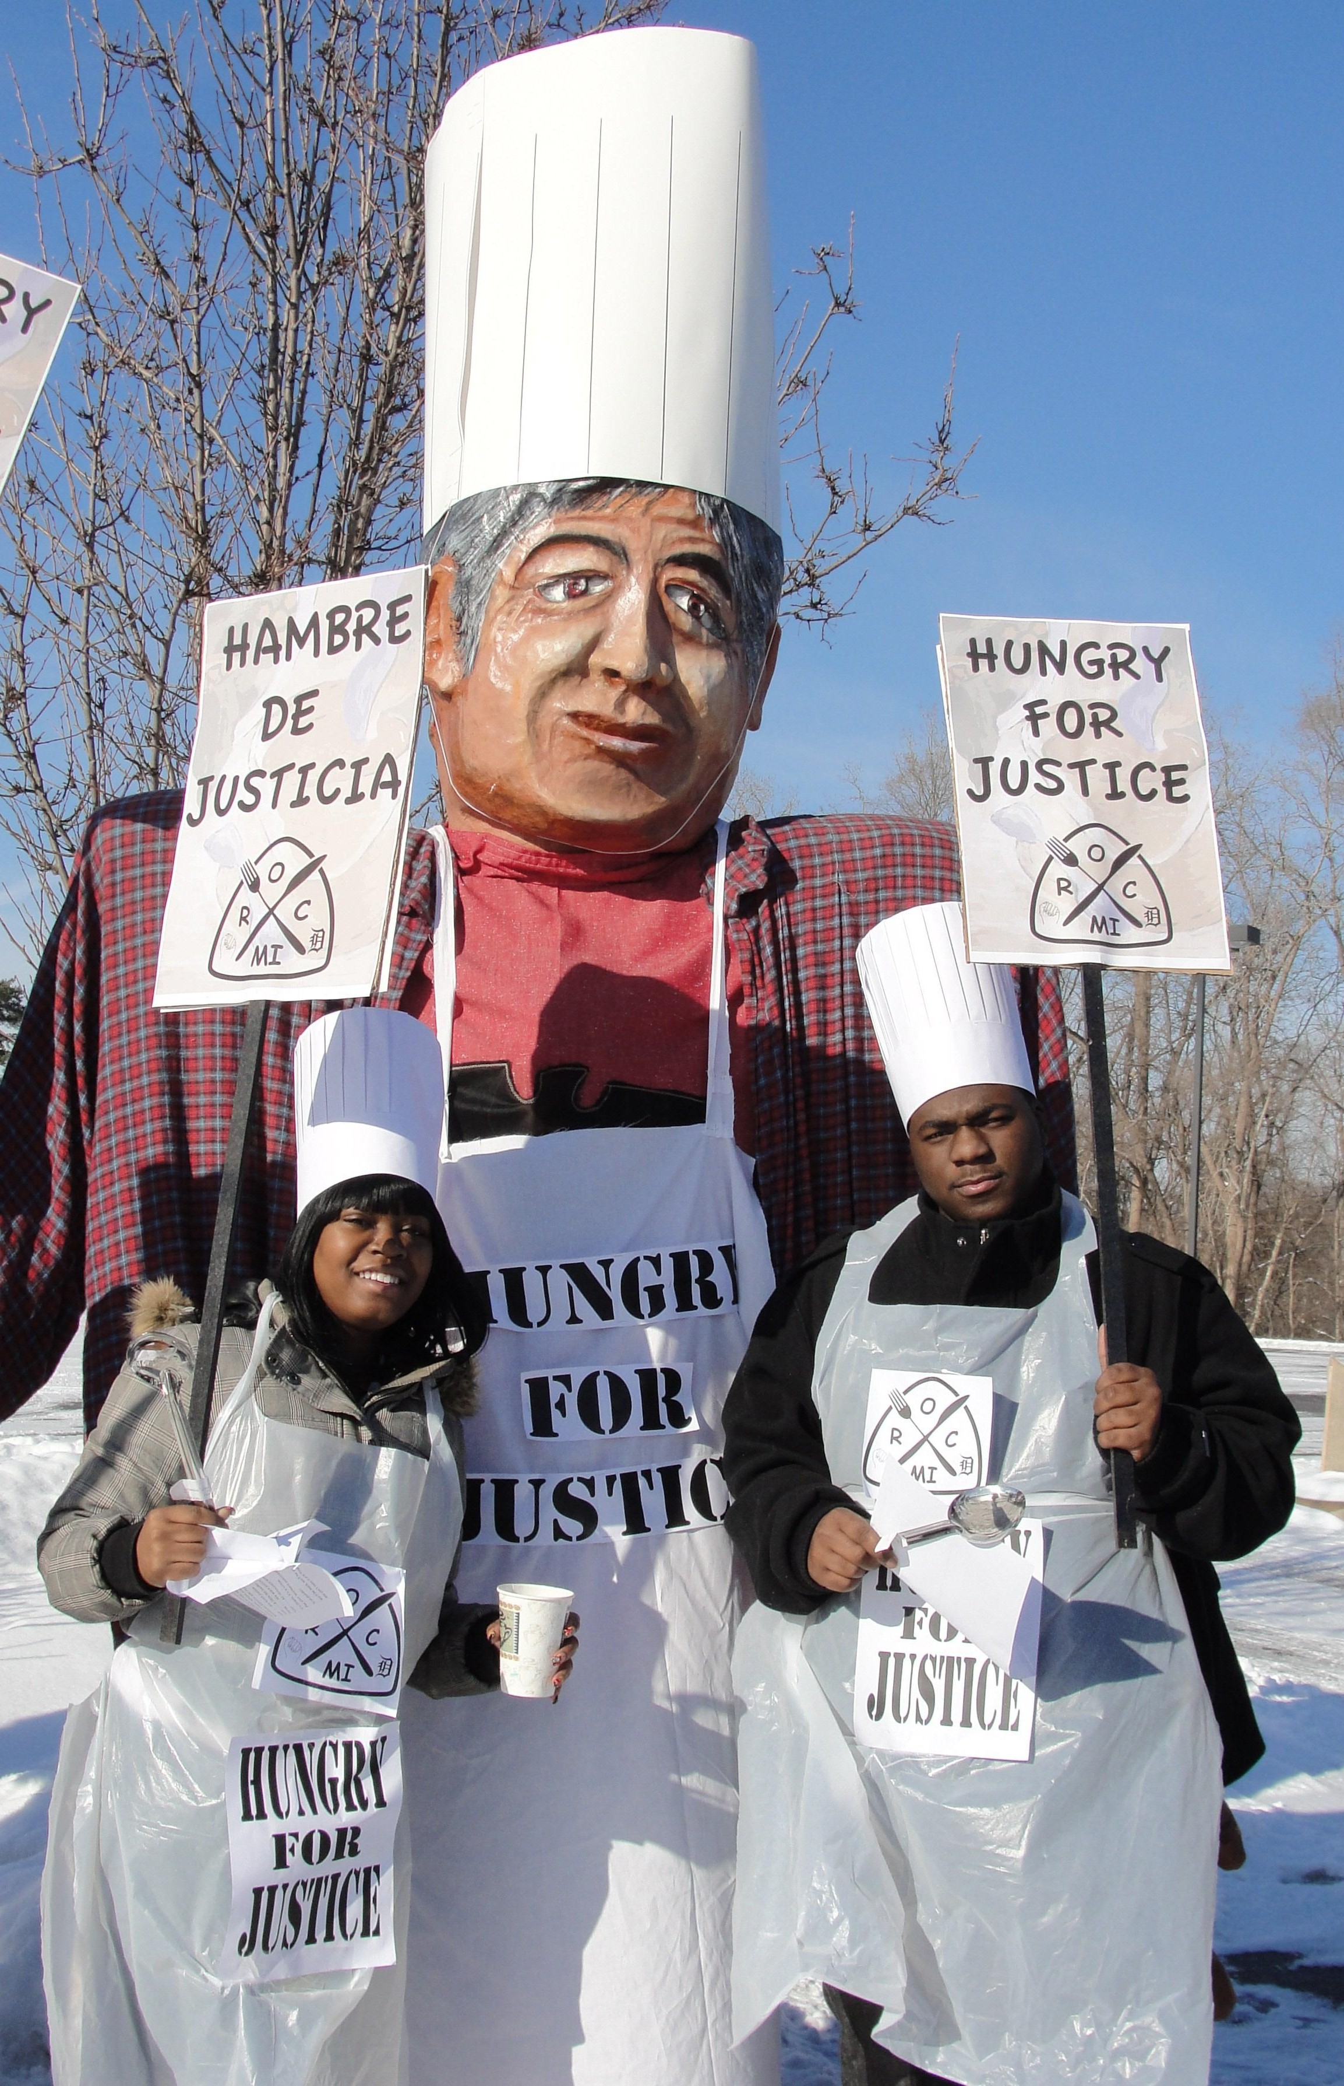  The Unitarian Universalist Service Committee (UUSC), a human-rights and social-justice organization, has joined in collaboration with the Food Chain Workers Alliance (FCWA) to advance the rights of food-system workers to work in dignity for a living wage and to organize in defense of their labor rights.  The mission of the FCWA is to improve the wages and working conditions of food system workers and their families. Together, Alliance members are working to end poverty and hunger, build a more sustainable agricultural and food production system, and achieve social, racial and environmental justice, as well as respect for workers’ rights. Learn more about FCWA at www.foodchainworkers.org.  UUSC’s Economic Justice Program supports and strengthens the movement for workers’ rights in the United States and overseas by partnering with grassroots groups that are developing innovative strategies to improve wages and working conditions for workers, farmers, traders, and their families. Learn more at www.uusc.org/economicjustice.  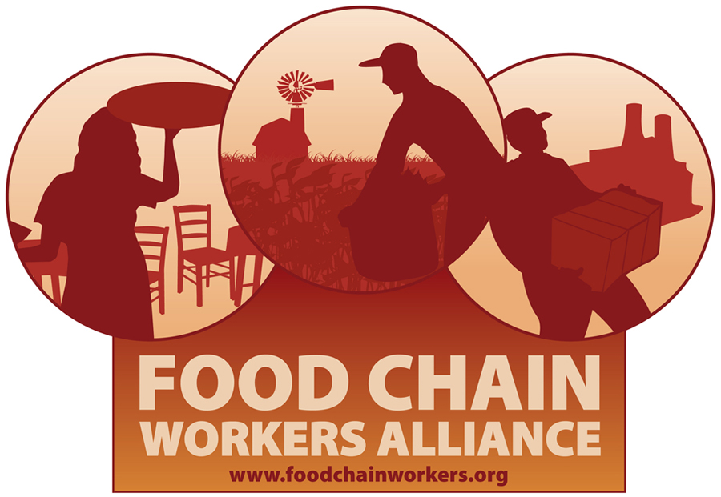   | The Unitarian Universalist Service Committee (UUSC), a human rights and social justice organization, has joined in collaboration with the Food Chain Workers Alliance (FCWA) to advance the rights of food-system workers to work in dignity for a living wage and to organize in defense of their labor rights.  The mission of the FCWA is to improve the wages and working conditions of food system workers and their families. Together, Alliance members are working to end poverty and hunger, build a more sustainable agricultural and food production system, and achieve social, racial and environmental justice, as well as respect for workers’ rights. Learn more about FCWA at www.foodchainworkers.org.  UUSC’s Economic Justice Program supports and strengthens the movement for workers’ rights in the United States and overseas by partnering with grassroots groups that are developing innovative strategies to improve wages and working conditions for workers, farmers, traders, and their families. Learn more at www.uusc.org/economicjustice.

